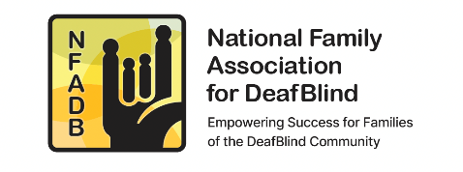 | NATIONAL FAMILY ASSOCIATION FOR DEAF-BLIND
 | Policy: Treasurer Roles and Responsibilities
 | Date Effective: 4.7.2019 | Date Revised: 4.9.2024

NFADB Bylaws Article IV, Section 8.
TREASURER. The Treasurer shall keep or cause to be kept complete and accurate accounts of the receipts and disbursements of the Association. The Treasurer shall deposit or cause to be deposited all funds, securities, instruments, and other valuable documents in the name and to the credit of the Association in banks or depositories designated by the Board. At the annual meeting, the Treasurer shall provide reports showing: (a) the assets and liabilities of the Association as of the end of a twelve-month fiscal period terminating less than six months before the meeting; (b) the principal changes in assets and liabilities during that period; (c) the revenues or receipts of the Association, both unrestricted and restricted to particular purposes during that period; and (d) the expenses and disbursements of the Association for both general and restricted purposes during that period. The report shall be filed with the minutes of the meeting. The report may consist of Association reports to the Internal Revenue Service or the Attorney General of the State of New York. The Treasurer shall make the Association's books and accounts available to any Member, Director, or Officer upon request at all reasonable times, render a statement of the Association’s accounts whenever required by the Board, and perform the other duties customarily incidental to the office or assigned by the Board.
____________________________________________________________________________

Specific Roles and Responsibilities:

Chair the Finance committee and support its mission to provide oversight responsibilities to ensure NFADB is fiscally responsible with respect to budgeting, safeguarding assets, financial reporting, and compliance with federal and New York state tax reporting.

- Review all requests for reimbursement and payment and upon approval will see that bills/reimbursements are paid in a timely manner.
- Present an accounting of the organization’s finances at all Board meetings.
- Work with Administrative Assistant on issues related to the organization’s finances and banking.
- Develop an annual budget and specific event budgets.
- Keep accounting software up to date for reporting.
- Select and communicate with an Accountant with the approval of the Finance committee, negotiating engagement and execution of an engagement letter.
- Provide information to Accountant to ensure timely filing of annual IRS Form 990 and NYS 550 CHAR.
- Monitor petty cash fund maintained by Administrative Assistant.
- Monitor Sunshine Fund income and expenses according to Sunshine Fund Policy.
- Work with the Finance committee to ensure policies and procedures provide adequate financial controls.
- Work with the Finance committee to ensure adequate controls over payment authorizations, including check signing, credit card use and access of all Association accounts.
- Responsible for adhering to the Association Document Retention and Destruction Policy, Budget Policy and the Financial Controls Policy.
- Member of the Executive Committee.

