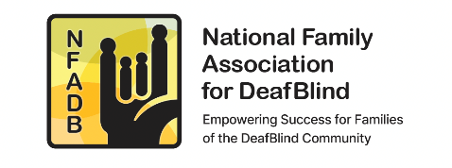 | NATIONAL FAMILY ASSOCIATION FOR DEAF-BLIND
 | Policy: President Roles and Responsibilities
 | Date Effective: 7.2019 | Date Revised: 4.9.2024

NFADB Bylaws Article IV, Section 5.

PRESIDENT. The President shall oversee the activities of the Association, preside at meetings of the Members and the Board, and perform the other duties customarily incidental to the office or assigned by the Board. The President shall have the power to unilaterally sign and execute all contracts on behalf of the Association when generally or specifically authorized by the Board, except when the Board requires an additional signature. The President shall keep the Board fully informed about the activities of the Association.
____________________________________________________________________________

Specific Roles and Responsibilities:
- General responsibility for and supervision over the activities of the Association.
- Preside at all meetings of the Membership and the Board;Executive Committee Chair.
- Set up a schedule of Board meetings (face to face and web conferencing) for the year.
- Establish board meeting agendas with help of the Executive Committee.
- Work with the Secretary to get the agenda and supporting documents to the full Board and Advisors prior to the meetings.
- After the meetings, work with the Secretary to review meeting notes prior to sending them to the entire board.
- Ensure that the dates and agenda for the annual NFADB meeting are posted on the Association's website.
- Provide an annual written report on all activities of the Association. Include the input from all board members in the report.
- Represent Association at identified conferences or meetings, or appoint an alternate.
- Appoint the Nomination Committee Chair annually.
- Member of the Finance Committee. Signs checks, oversees bank accounts, monitors bank balances and approves all expenditures of the Association.
- Sign tax returns from the accountant promptly and any other Agreements entered into by the Association.
- When organizing an event (Symposium, Conference, etc) participate in committees (promotions, organization, and fundraising).
- Send personal Thank You notes as needed (donors, collaborators, volunteers).
- Supervise Administrative Assistant; redirect emails to the right parties, reply to phone requests with the assistance of the Secretary (see list of tasks of Adm. Assist).
- Negotiate with partner organizations: office space & equipment (HKNC) and financial support for Adm. Assist. (NCDB), maintain relationship with Perkins.
- Initiate dialogue with other parties when new ideas are suggested by the EC or Board.

